***Повторення.***

*25.05.2022 9Б Хоменко А.Ю.*

*Хід уроку.*

1. ***Writing.***

Answer the questions.

1. What rubrics in newspapers or magazines do you like reading most of all?

2. Do you like reading political news?

3. Where do you usually know political or cultural news from?

4. Have you ever written to a newspaper or to a magazine?

1. **Reading.** ( шановні діти, прочитайте та перекладіть текст усно.

The New York Times is only one of many daily newspapers that have become significant shapers of public opinion. Among the most prominent are the “Washington Post”, the “Los Angeles Times”, the “Boston Globe” and the “Christian Science Monitor”. The “Miami Herald”, for instance, responded to the needs of Spanish-speaking residents by presenting expensive coverage of Latin America and printing a separate Spanish edition. Satellite technology has made possible the first genuinely nationwide newspapers — from the sober, thorough business paper, the “Wall Street Journal”, to the bright colors and personality orientation of “USA Today”.

But the largest readerships were won by magazines that catered to Americans’ increasing leisure time and appetite for consumer goods, such as “Cosmopolitan”, the “Ladies Home Journal” and the “Saturday Evening Post”. Publishers were no longer just selling reading material: they were selling readers to advertisers.

1. ***Grammar. (****на уроці повторення, обов'язково треба повторити граматику, щоб вміти правильно складати речення англійською мовою. Пропоную опрацювати Past Continuous Tense.) Перегляньте табличку і складіть 6 речень усно ( 2 стверджувальних, 2 заперечних, 2 питальних).*

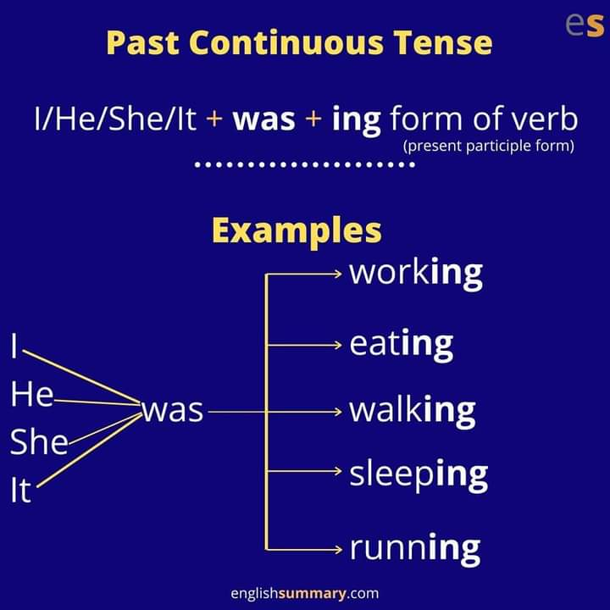

**Home work**: Шановні діти, пропоную повторення

* дати письмово відповіді на питання письмово
* опрацювати текст усно
* повторити граматику в Past Continuous Tense.
* Ваші роботи чекаю на платформі Human.